USDA COVERED SPECIES ANESTHESIA/POST-PROCEDURAL MONITORING RECORDS

- In USDA covered species (all mammals except for mice of the genus Mus and rats of the genus Rattus) the following must be recorded in an individual animal record for each anesthetic event:
  - Date
  - Principal Investigator
  - Animal Protocol number
  - Animal ID
  - Species
  - Weight
  - Procedure
  - Agent(s) used, dosage, route of administration
  - Time of induction of anesthesia
  - Time of recovery from anesthesia
  - Monitoring every 15 minutes including:
    - Temperature
    - Heart Rate
    - Respiratory Rate
    - For small mammals such as paramiscus, hamsters, gerbils, etc. monitoring for normal heart rate, respiratory rate and temperature may be sufficient as it is difficult to assess these parameters quantitatively.
- Post-anesthesia monitoring should be performed until the animal is ambulatory (able to stand and walk). No animal should be returned to OAR animal facilities until they are ambulatory.
- For surgical procedures record the following in addition to what is listed above:
  - Post-operative monitoring- must be done at least daily (including weekends and holidays) for the first 5 days unless otherwise stipulated in the IACUC approved animal protocol
    - Date
    - Time
    - Brief description of the animal’s health status and surgery site appearance
  - Analgesia (for each administration)
    - Date
    - Time
    - Dose
    - Route
  - Date when wound clips, staples or sutures are removed, if applicable
- The templates provided are an example for recording anesthesia and post-surgical monitoring for large animals. Alternatively you can develop your own form or edit these templates to fit your needs. Whatever form is used, it must contain all of the informational elements noted above.

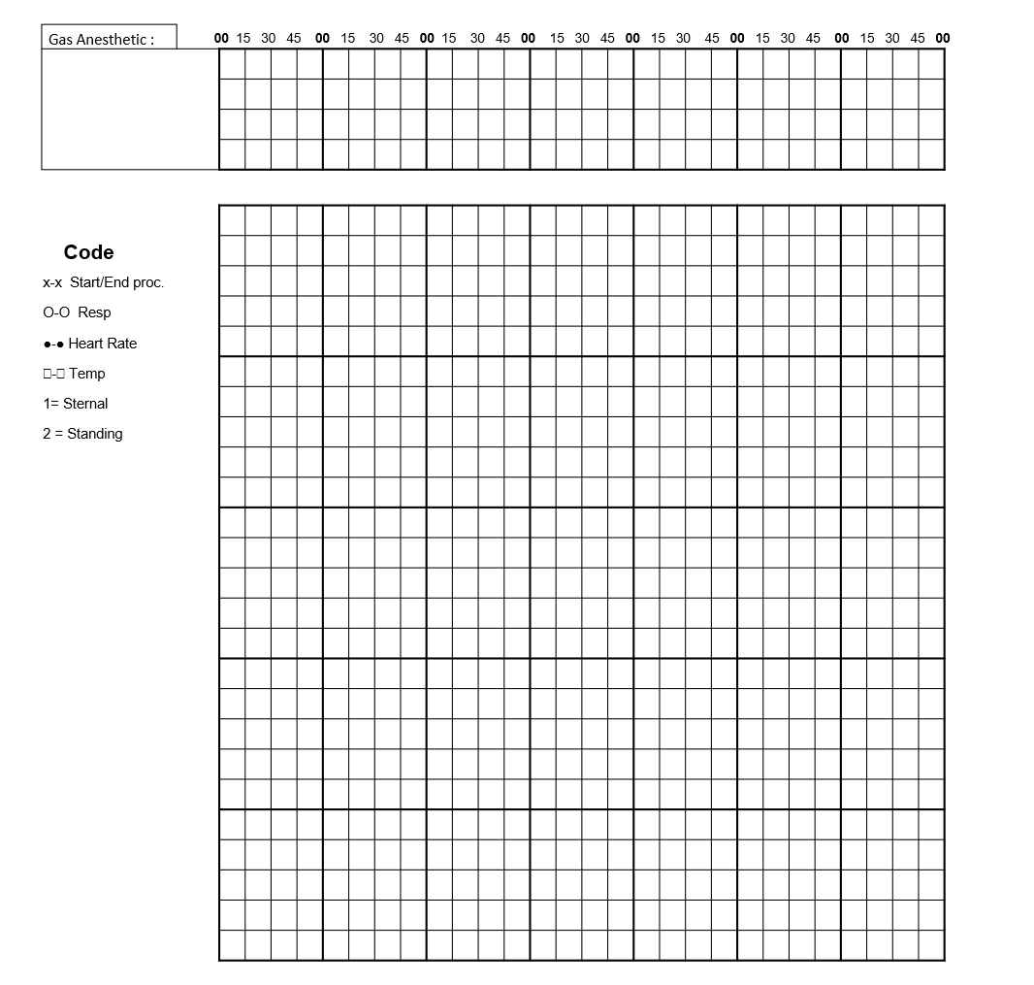

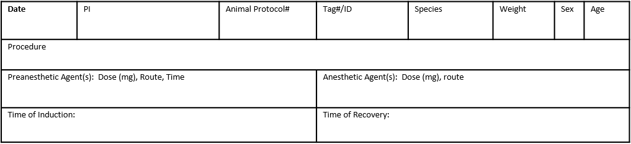
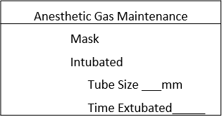
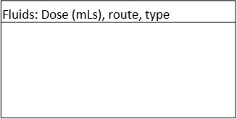
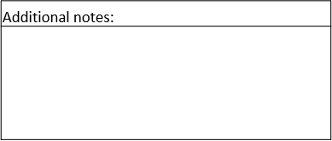
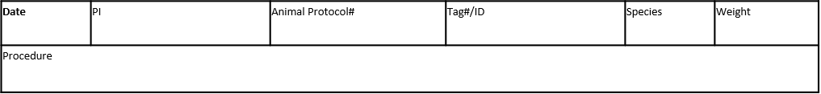
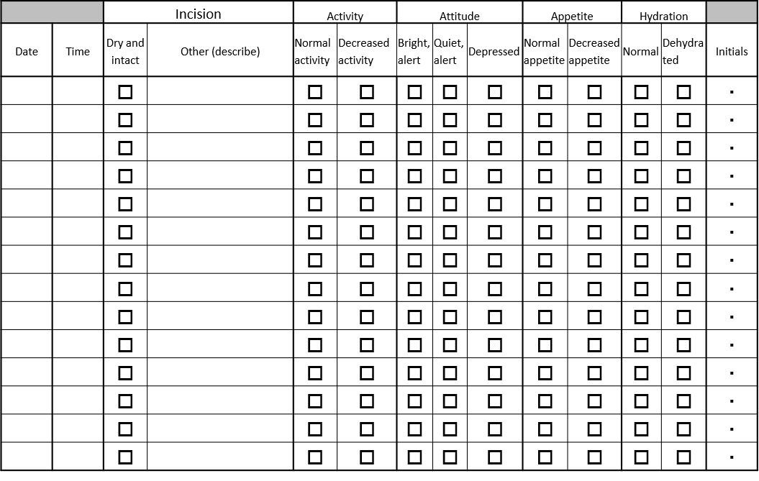
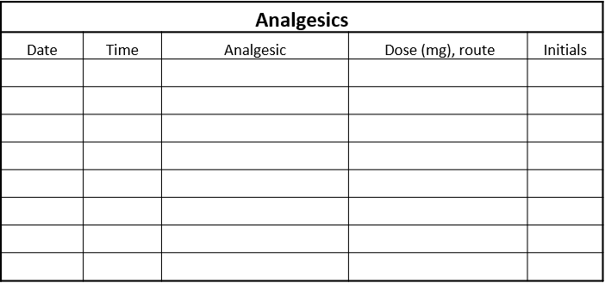
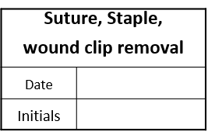
USDA SPECIES ANESTHESIA RECORD TEMPLATE
Isoflurane
Sevoflurane
3%
2%
1%
Anesthesia Monitoring of the animal must be done AT LEAST EVERY 15 MINUTES
Temperature
USDA COVERED SPECIES POST-OPERATIVE RECORD TEMPLATE

